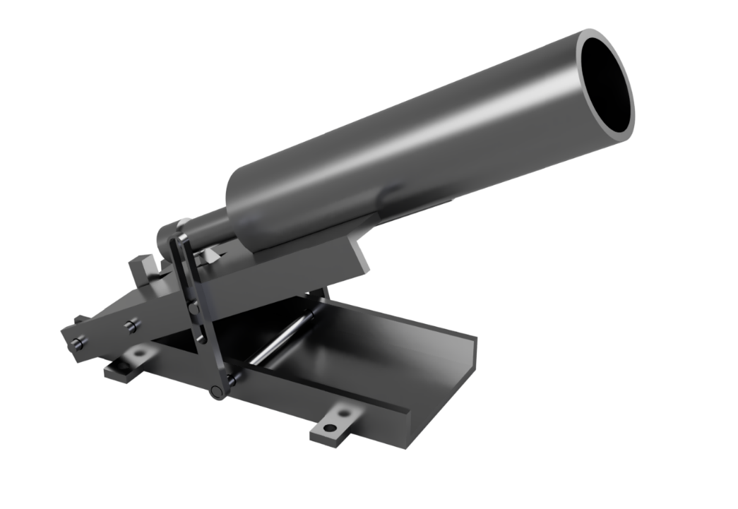

(Rendered on Autodesk Fusion 360)

Line Launcher Report

Semester Project | Engineering Materials (ME-221) | 6 June 2020

|  |
| --- |
| **Group: 5 ME-11 C** |
| Huzaifa Irfan (285501) |
| Rana Sohaib Ullah (286694) |
| Abu Huraira (284624) |
| Hassaan Ahmad (284811) |
| Hassan Ahmad (289686) |

Contents

**Abstract** 2

**Motivation** 3

**Outline of Approach** 4

**Material Selection** 4

**Components** 4

**Working Principle** 4

**Range** 4

**Fabrication Steps** 4

**Short Commings in Device** 4

**Conclusion** 5

**Analysis of Final Design** 6

**Final design of linE launcher** 6

**Structural analysis** 7

**Base plate and movable plate** 8

**Main pipe** 9

**Striking rod and spring assembly** 10

**Trigger** 10

**Link** 10

**Striking Lock** 10

**System analysis** 11

**Relation between angle and range:** 11

**Relation between angle and height:** 11

**Relation between range and velocity:** 11

**Working analysis of device** 12

**Error Sources** 13

**Conclusion** 14

**Annex A (Cost Analysis)** 15

**Annex B (Multi Views of Components)** 16

**Annex C (Assembly and Component Design/ 3D Models)** 18

**3D Models of Components** 18

**Bibliography** 19

# **Abstract**

To make the project of linear launcher and its report by working on the data we have during the past years with the help of our course and the past experiences of making the project of mouse trap car.

# **Motivation**

This project is assigned by the science society IMECHE. So, at first, we are inspired by the society as well. The main motivation behind the project making is discovering the science and its fundamental principles that is why we choose the path of engineering as our passion and profession. Recently, in the last semester, me and my teammates work on the project of mouse trap car which was assigned by the ASME NUST. Also, that project led and motivated us to make another practical example so that we can show our technical skills.

# **Outline of Approach**

## **Material Selection**

We are going to select:

* Best possible material in low price
* Material that is easily available
* Cheapest material for our convenience

## **Components**

* Base plate
* Movable plate
* Striking rod and spring assembly
* Main pipe
* Link
* Trigger

## **Working Principle**

* Law of conservation of energy
* Elastic potential energy is main power source
* First, we store energy in the spring
* Then spring release its energy ang give it to the ball

## **Range**

Range depends upon:

* Stiffness of spring
* Angle of projection
* Maximum range angle is between 40 and 50 degrees

## **Fabrication Steps**

* Base plate and movable plate joined first
* Striking rod and spring assembly places inside main pipe
* Main pipe joined with movable plate
* Then trigger will attach to the pipe

## **Short Commings in Device**

* Angle measurement
* Rotation of movable plate along only one axis
* Rough surface of pipe from inside
* Air resistance

## **Conclusion**

* The design of this device is most probably the best possible design in our point of view but there are always shortcomings and defects in any engineering device. But we did our best to select a design that has minimum shortcomings.

# **Analysis of Final Design**

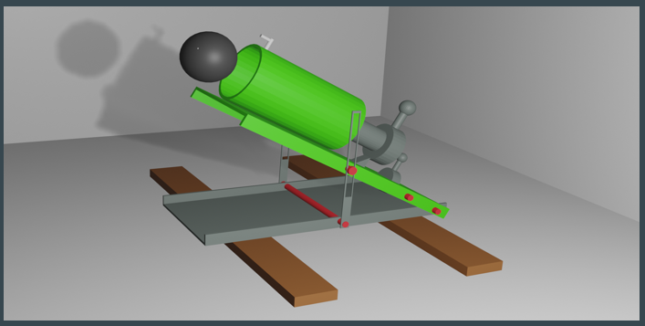

Figure 1 - First Design (Modelled and Rendered in Blender)

The Design for this project is final so far. Due to CoVid-19 Lockdown, it may be changed during fabrication after the reopening of Universities and Markets.

## **Final design of linE launcher**

The Final design (Modelled Using Auto Desk Fusion 360) and multi views of the Line Launcher is shown in the Figure 2 and Figure 3 respectively.

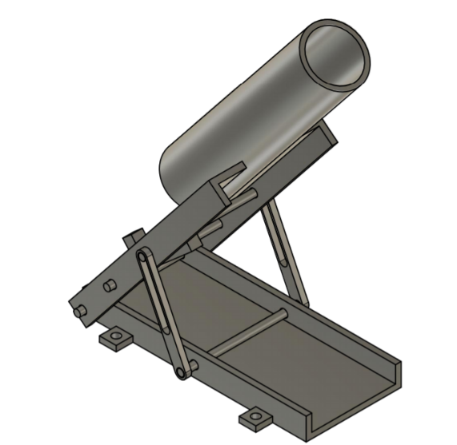

Figure - Final Model Design (Modelled on Autodesk Fusion 360)

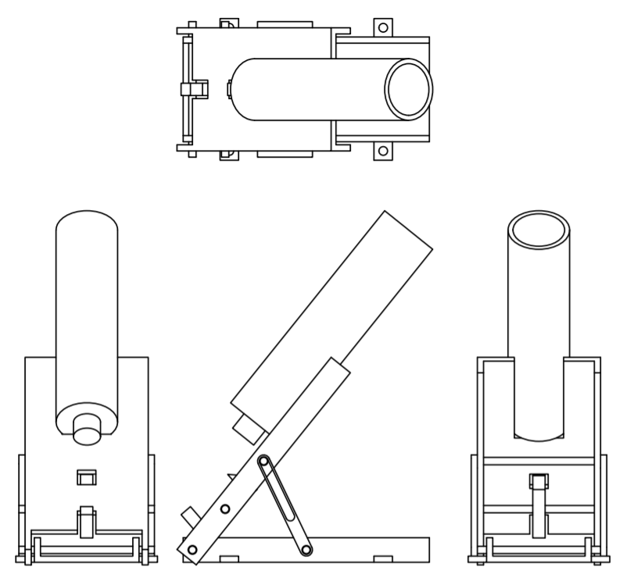

Figure - Multi Views

## **Structural analysis**

Line launcher consists of following parts as shown in the Figure 4 and Table 1. The Multi views of components are available under Annex B And 3d Models of full assembly and components is available under Annex C.

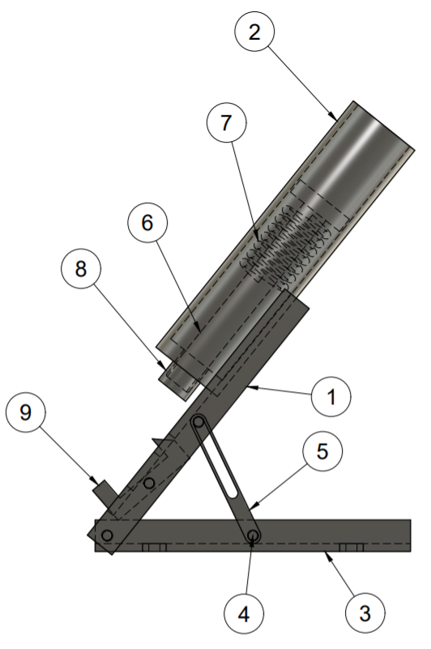

Figure - Components

|  |  |  |
| --- | --- | --- |
| **Item** | **Qty** | **Part Name** |
| 1 | 1 | Moveable Plate |
| 2 | 1 | Main Pipe |
| 3 | 1 | Base Plate |
| 4 | 4 | Axis Rod |
| 5 | 2 | Link |
| 6 | 1 | Striking Rod |
| 7 | 1 | Spring |
| 8 | 1 | Striking Lock |
| 9 | 1 | Trigger |

Table - Parts List

### **Base plate and movable plate**

Base plate and movable are made up of steel sheet thickness of 1mm approx. Movable plate is joined with base plate in such a way that the movable plate will able to move along one specific axis. The base plate is bearing all weight and is supporting moveable plate over it.

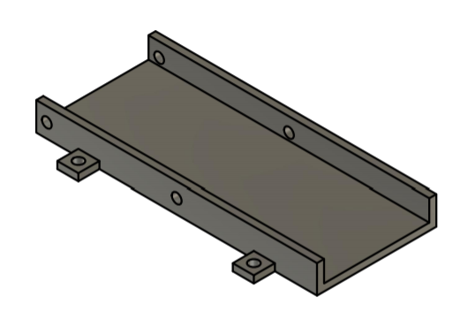

Figure - Base Plate

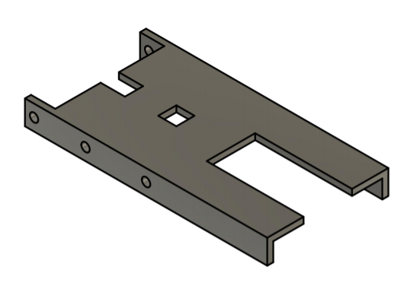

Figure - Movable Plate

### **Main pipe**

The main pipe is made up of hard plastic. The pipe is attached at the top of movable plate. So, this will help in moving main pipe and movable plate together.

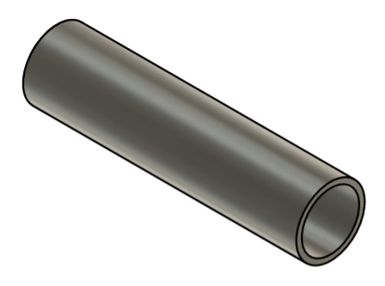

Figure - Main Pipe

### **Striking rod and spring assembly**

Striking rod is also made up of hard plastic. It is placed inside the main pipe with spring attached to it. This all works on the energy stored in the spring. More the stiffness of the spring, more will be the energy stored.

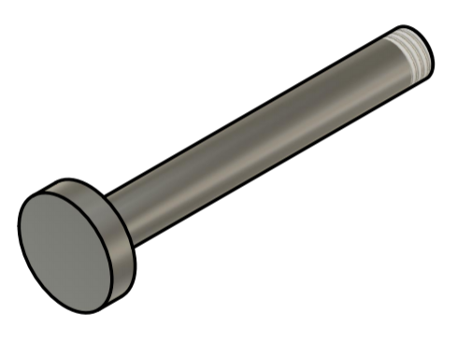

Figure - Striking Rod

### **Trigger**

The trigger is made of the plastic or metal. It connects with the moveable plate and its one end is present at the empty slot present in the center of the moveable plate which serves as the lock. While the other end is act as trigger.

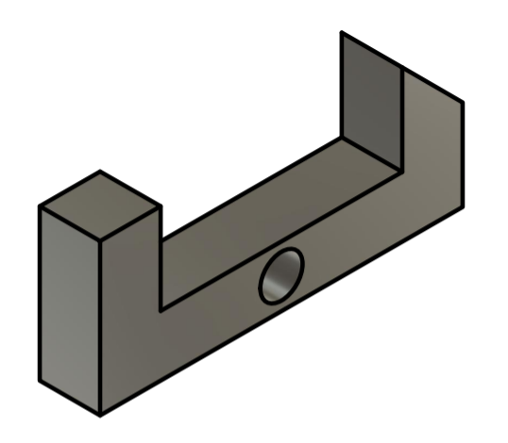

Figure - Trigger

### **Link**

The link is also made of the plastic or metal. It is the connection between the base plate and the moveable plate. It serves as the angle changer between the two plates due to which the angle of projection also changes. Link is joined with base plate as well as movable plate with the help of axis rod.

Figure - Link

### **Striking Lock**

Striking Lock holds the striking rod. This will help in projecting the ballon the choice of the performer of experiment. It holds the trigger and striking rod so that the rod will not release its energy at any instant, but it will push the ball when required with the help of trigger.

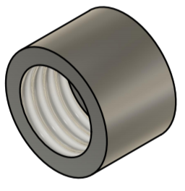

Figure - Striking Lock

## **System analysis**

In system analysis, the working elements like range, the angle and height and on what factor range, angle and height of our device depends. And on changing these, what is the effect on the properties of device.

### **Relation between angle and range:**

Range and angle are related directly related according to the formula:

**R =**

This shows that when the angle increases, range also increases but this happen to a certain limit. Maximum range of launcher occurs at angle of 45 degrees. After 45 degrees the range starts decreasing.

### **Relation between angle and height:**

Height and angle are also directly related according to the formula:

**H =**

This shows that as angle increases the height also increases but to a certain limit of 90 degrees. Maximum height occurs at an angle of 90 degrees.

### **Relation between range and velocity:**

Range is directly proportional to the velocity. As velocity increases range of our device also increases and velocity of our device depends upon stiffness of the spring. Stiffer the spring more energy it stores so more will be the velocity. Formula for range is:

**R =**

## **Working analysis of device**

Following are the steps that describe the working of our device:

* Movable plate allows to move along only one axis.
* This device works on law of conservation of energy.
* First, we mechanically store energy in the spring.
* This can be done by compressing the spring.
* Once the spring is fully compressed, then it is ready to transfer its energy to the ball.
* This can be done by relaxing the spring with the help of trigger.
* It will relax the striking rod and ball is pushed.
* Velocity of the striking rod depends upon the stiffness of the spring.
* Stiffer the spring, more will be the energy stored and more will be the energy given to the ball so larger will be its velocity.
* Measurement of angle can be done with the help of a protector.
* Closer the angle to 45 degrees, larger will be the range.

# **Error Sources**

**Expected shortcomings in device:**

* Every engineering device must have some short comings.
* Related to linear launcher project we will do over best to reduce the shortcomings.
* But that is not possible that all the short comings will be removed.
* But it is possible that their number will be reduced.
* So as a student of mechanical engineering it is our duty to reduce the shortcomings.
* Here is the list of some expected shortcomings that we will face when we will fabricate our project after the reopen of university.

**1. Angle measurement:**

* Angle measurement is a defect of our expected device that we will make because will not designing any instrument for measurement. We will measure angle with the help of protector without any special instrument attached with device. So, our angle may have an uncertainty of almost 2%.
  + So, this will be the first expected shortcoming of our expected device.
  + But we will try to reduce the uncertainty in angle by taking an average reading of angle.

1. **Rotation of movable plate along only one axis:**

* The movable plate which is on the base plate is only movable along x-axis.
* The movable plate is restricted to move along y-axis and along z-axis.
* This is another expected shortcoming of our expected device.
* The design of our device will allow movement along only one axis.

1. **Friction in the pipe and air resistance:**

* This is the natural shortcoming of every mechanical device. We will not overcome air resistance but friction in the pipe can be overcome by the help of lubrication but will not be erased completely.

# **Conclusion**

The final report of line launcher contains accurate results. The actual calculations were almost equal to the theoretical calculations. The prototype design was cheap to manufacture and easy to use with little user training required. Some changes can also be made to make it easier to use.

# **Annex A (Cost Analysis)**

|  |  |  |
| --- | --- | --- |
| **Sr NO.:** | **Description** | **Price** |
| **1** | Metal Sheet*2 | 75*2=150 |
| **2** | A Pipe | 30 |
| **3** | Striking Rod & Spring Assembly | 70 |
| **4** | Link | 70 |
| **5** | Electric Switch | 50 |
|  | **Total** | 370 |

Table - Cost List

# **Annex B (Multi Views of Components)**

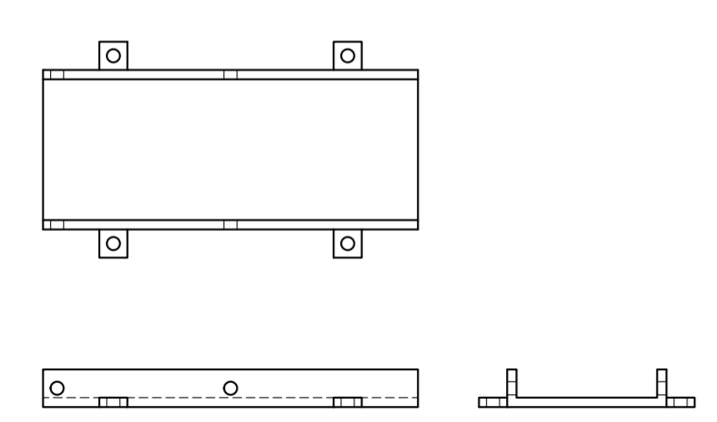

Figure - Main Plate

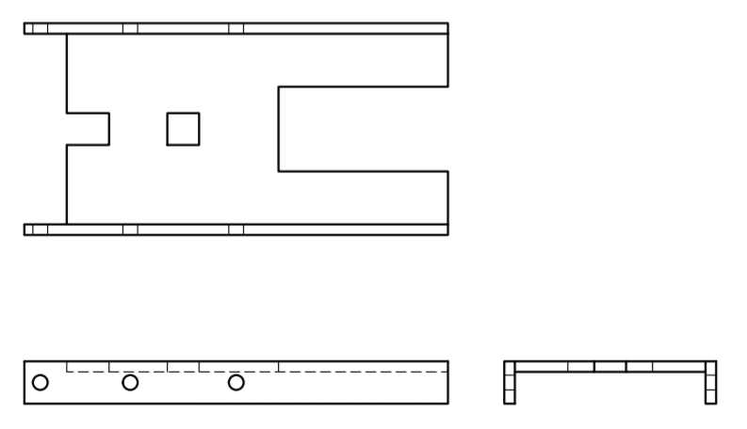

Figure - Movable Plate

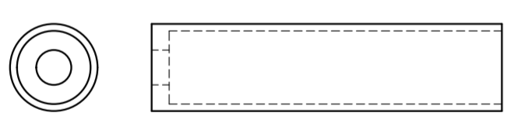

Figure - Main Pipe

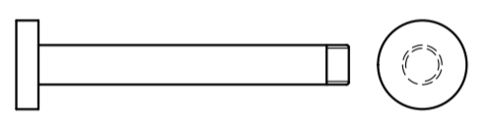

Figure - Striking Rod

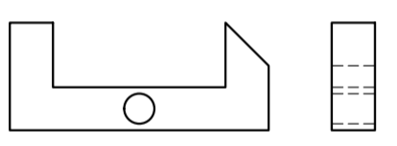

Figure - Trigger

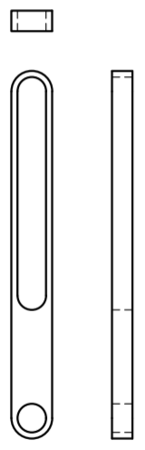

Figure – Link

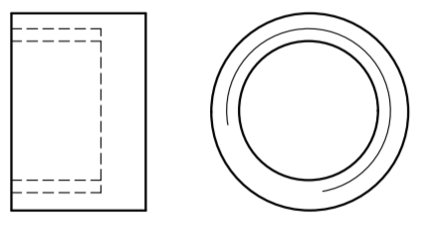

Figure - Striking Lock

# **Annex C (Assembly and Component Design/ 3D Models)**

All these components and model are created using Autodesk Fusion 360 and are available for viewing on browser, mobile or pc.

* **Whole Assembly:** [**https://a360.co/2AG54FY**](https://a360.co/2AG54FY)

## **3D Models of Components**

* **Axis Rod:** [**https://a360.co/3gZwdo0**](https://a360.co/3gZwdo0)
* **Base Plate:** [**https://a360.co/2MDdNuY**](https://a360.co/2MDdNuY)
* **Striking Lock:** [**https://a360.co/3f8bmx5**](https://a360.co/3f8bmx5)
* **Trigger:** [**https://a360.co/3h00XoN**](https://a360.co/3h00XoN)
* **Link:** [**https://a360.co/2Y602dL**](https://a360.co/2Y602dL)
* **Main Pipe:** [**https://a360.co/3dEsiKV**](https://a360.co/3dEsiKV)
* **Movable Plate:** [**https://a360.co/3cANjF7**](https://a360.co/3cANjF7)
* **Spring:** [**https://a360.co/2BEMqPb**](https://a360.co/2BEMqPb)
* **Striking Rod:** [**https://a360.co/3dEbqnN**](https://a360.co/3dEbqnN)

# **Bibliography**

*Design a Projectile Launcher*. (n.d.). Retrieved from Green Mechanic: https://www.green-mechanic.com/2016/10/assignment-2-design-projectile-launcher.html#more

*Projectile Launcher Mechanical Engineering Project*. (n.d.). Retrieved from Youtube: https://www.youtube.com/watch?v=MikDdTkkSJ8

*Projectile motion*. (n.d.). Retrieved from Wikipedia: https://en.wikipedia.org/wiki/Projectile_motion

**--The End--**